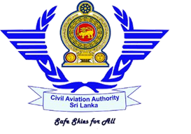
Civil Aviation Authority of Sri Lanka
Approved Flying Training Organizations
Status Quo Analysis of Skyline Aviation (Pvt) Ltd
As at 31/01/2021

- General Profile – Approved Training Organization

Trade Name | Licence Number | Licence Status
No 104/3 New Airport Road, Rathmalana | No: Seven (7) | Last Renewed Date | Validity Period
 |  | 27th August 2020 | 27th August 2020 – 18th February 2021

- Flying Training Programmes: 05

- Private Pilot License (Aeroplane)
- Commercial Pilot License (Aeroplane)
- Instrument Rating (Aeroplane)
- Assistant Flight Instructor Rating (Aeroplane)
- Airline Transport Pilot License (Theoretical Knowledge)

- Aircraft Types, & Procedure Trainer/ Simulator
Aircraft Types – Currently used | Cessna 152 4R-SAY
 | Cessna 152 4R-SAZ

- Key Post Holders
Posts | Person Name
Accountable Manager | Mr. K A Romesh Fernando
Head of Training | -
Chief Flight Instructor | Mr. S. S. Gamage
Chief Theoretical Knowledge Instructor | Mr. T. Abeyratne
Compliance Monitoring Manager | Mr. G.L. Jayathilaka
Safety Manager | Mr. P B S de Silva
Flight Instructor | Mr. S. S. Gamage

- Student Details (as per the statistic report of December 2020)
PPL | CPL | ATPL | Other | Remarks
Flying 02 |  | Ground 02

