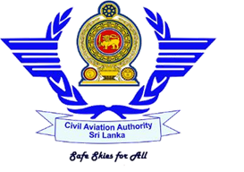
Civil Aviation Authority of Sri Lanka
Approved Flying Training Organizations
Status Quo Analysis of Fits Air Flight Academy
As at 31/01/2021

- General Profile – Approved Training Organization

Trade Name | Licence Number | Licence Status
No. 06, Joseph Lane, Colombo 04 | No: Nineteen (19) | Last Renewed Date | Validity Period
 |  | 28th August 2020 | 28th August 2020 – 1st September 2021

- Flying Training Programmes: 05

- Private Pilot License (Aero plane)
- Commercial Pilot License (Aero plane)
- Instrument Rating (Aero plane)
- Assistant Flight Instructor Rating (Aero plane)
- Airline Transport Pilot License (Theoretical Knowledge)

- Aircraft Types & Procedure Trainer/ Simulator
Aircraft Types – Currently used | Cessna 152 4R-FAA
 | Cessna 152 4R-FAB

- Key Post Holders
Posts | Person Name
Accountable Manager | Capt. Mohamed Ameen
Head of Training | Capt. M R Dassanayake
Chief Flight Instructor | Capt. M R Dassanayake
Chief Theoretical Knowledge Instructor | Mr. J K P N S Perera
Compliance Monitoring Manager | Mr. M A P Perera
Safety Manager | Mr. Y. N. A. Kumariah
Flight Instructors | Capt. M R Dassanayake  Mr. B K U M Rodrigo

- Student Details (as per the statistic report of December 2020)
PPL | CPL | ATPL | Other | Remarks
Ground 09  Flying 12 | Flying 04 | Ground 05

